DATE: 30/03/2018
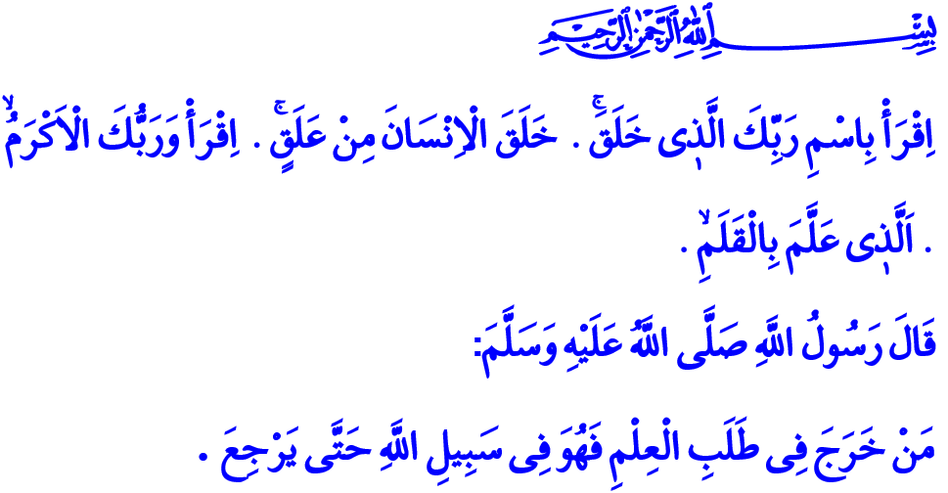
THE FIRST MESSAGE OF REVELATION TO HUMANITY: READ!
Jumu’ah Mubarak, Honorable Believers!
The first verses revealed to our Prophet at Cave Hira are those I recited at the beginning of the khutbah. In those verses, Allah states: “Read in the name of your Lord who created - Created man from a clinging substance. Read, and your Lord is the most Generous - Taught man that which he knew not.”
Our beloved Prophet, who was the addressee of this command, declared in a Hadith: “Whoever goes out seeking knowledge is in Allah's cause until s/he returns.”
Brothers and Sisters!
As a noble creature, man is bestowed with the unique gift of intellect. It is intellect, the ability to discern good from evil, that separates man from other beings and imparts him with value. Intellect is the source of man’s sense of responsibility and his tool in choosing between right and wrong. Servants of Allah realize His message through intellect and set it as their guide in life. They understand and fulfill their responsibilities to themselves, to Allah, and to those around them using intellect. They learn, teach, live and let live by means of their minds.
Esteemed Believers!
The one purpose of man worth toiling, suffering, and laboring the most for is knowledge acquisition. Knowledge is the treasure that enlightens the path of mankind and wisdom is the most honorable rank for man to attain. Thus begins the first book of the last revelation with the words “Read!”. For reading is the pursuit of virtue. Reading is reaching the truth. Reading is the closest companion of people on their journey of exploration of the meaning behind creation, life and the universe. Our Holy Book suggests, 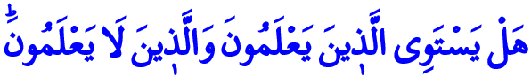 “Are those who know equal to those who do not know?” to emphasize the value of knowledge and the indispensability of wisdom for mankind. Our gracious book the Qur’an, the divine spring of wisdom, orders us to think, to use our intellect and reach true knowledge, criticizing ignorance with warnings such as,  “…turn away from the ignorant!” 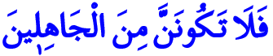 “So never be of the ignorant!” For this reason, reading in order to learn our religious and social responsibilities, and embracing the Book and knowledge in order to discern between right and wrong, is the essential obligation of all Muslims.
Venerable Muslims!
Knowledge is for man. Man is exalted with knowledge. With the true knowledge from the correct sources, he reaches righteousness, steers the society and shapes the world. Wisdom grants peace, happiness, and earthly and heavenly prosperity to man whereas ignorance brings shame and deception, and leads to faults and harm.
Beloved Believers!
Al-Masjid al-Nabawi, built in Madinah by our Prophet, is a center for learning. Our Prophet (s.a.w.) invited all believers to his masjid, men and women, the young and the elderly, and heralded that Allah would ease the path of heaven for those dedicated to learning.
In our civilization, scholars are the ones who present knowledge, wisdom, morals, manners, righteousness and the truth to all humanity. They embody and represent these graces. For scholars know that knowledge untempered by wisdom and not embellished by scholarship is bound to create a heavy load in the Hereafter.
Honorable Believers!
We live in the age of information and technology. But mankind has often used these not for ensuring good on earth but instead abused them, and acted immorally. As knowledge is detached from morality, so are people detached from their inherent value as human beings. Many of the youth, deprived of the spirit of education and the meaning and purpose of knowledge are sent towards bigotry, violence and terror.
It is our duty to ensure peace and security in the Islamic geography plagued by oppression and ignorance, and to offer a new civilization to the world as Muslims. In this regard, it is our collective responsibility to pursue the true knowledge and correct sources, to receive knowledge from competent origins and to act in accordance with what we learn.
Brothers and Sisters!
Let us, as parents, raise our children with the conscience of faith fed by the Qur’an and Sunnah, with love of worship and the sense of morality. Let us strive for them to be good people and exemplary believers. Let us not deprive our children, whether boys or girls, of education provided by schools, mosques and Qur’an courses.
I would like to share a final consideration while ending my khutbah. It is the National Libraries Week in Turkey. Libraries are a source of learning and knowledge as they support the love of reading and reading habits. They are the places that instill us book-love. So let us appreciate their value. Let us all share the joy of spending our time reading in libraries.

Alaq, 96/1-5.
Tirmidhi, ‘Ilm, 2.
Zumar, 39/9.
A’raf, 7/199.
An’am, 6/35.
Tirmidhi, ‘Ilm, 19. General Directorate of Religious Services

